Knife Rose Acquired for Gloucester

Hundred Heroines is participating in Gloucester’s National Youth Anti-Violence Campaign
1st – 28th February

Hundred Heroines, the Gloucester based charity dedicated to celebrating women in photography, is pleased to announce its participation in Gloucester’s National Youth Anti-Violence Campaign and in the programming of events that will form part of the campaign’s legacy.

To coincide with the arrival of the Knife Angel – the National Monument for Serious Violence - Hundred Heroines has acquired a Knife Rose, thanks to the support of the Stronger, Safer Gloucester Partnership. The artwork, which will be unveiled at The Eastgate Centre on 1st February, was created by internationally acclaimed artist, Renate Bertlmann, as part of her 2019 installation in the Austrian Pavilion at the Venice Biennale.

The rose is made out of red glass (hand-blown in Murano) and the pistil has been replaced by a razor-sharp blade to represent the juxtaposition of “beauty and pain, power and weakness, vulnerability and attack” (Bertlmann, 2019).

Knives are the most widely used weapons in violent crimes against women and Hundred Heroines will be using the Knife Rose as a focal point to highlight the horrifying statistics, as well as the basis of a number of initiatives towards the elimination of violence against women, including an art activism project, conversations around toxic relationships and a wider photographic competition that anyone can enter.

“The word ‘femicide’ should not even exist” says Del Barrett, Chair and Founder of Hundred Heroines, “but it does exist because more than 100 women in the UK are killed by men each year, and many thousands more are injured and abused”.

Full details of the campaign and how to participate will be on the Hundred Heroines website in the New Year, but in the meantime, if you want to get involved, drop them a line: hello@hundredheroines.org.

For further information please contact Del Barrett
del@hundredheroines.org
+44 (0) 7831 487 606

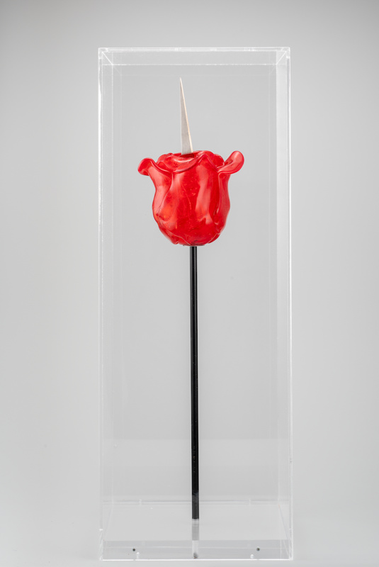 | Venice Knife-Rose, 2019 by Renate Bertlmann
Notes for editors
About Hundred Heroines
Gloucester based Hundred Heroines is the only UK charity dedicated to advancing public awareness of women in photography. As women photographers, ‘Heroines’ challenge how we see the world, push artistic and social boundaries, and highlight human rights issues. Through innovative exhibitions and events, Hundred Heroines showcases the invaluable contribution women make – and have made – to the visual arts and to society, while building a living archive that aims to increase public appreciation of their work and transformational humanitarian impact.
About Renate Bertlmann
Renate Bertlmann (b 1943) is an Austrian feminist avant-garde artist, who has explored issues around the representation of sexuality, eroticism and patriarchal violence, within a social context, since the 70s. Her artistic practice spans painting, drawing, collage, photography, sculpture and performance, confronting the social stereotypes assigned to masculine and feminine behaviour and relationships. Renate’s oeuvre includes sculptures that denounce male fantasies of violence against women, and works that focus on the oppression of women.

