

Getting ready for Secondary School!

This workbook belongs to ..................................................................



Moving to Secondary School is both exciting and scary! You will meet new teachers, make new friends, and get used to a new routine. This workbook will help you to manage all of those changes.

All About Me



Draw a picture of yourself here or stick in a photo!

My name: ..................................................................

My birthday: ..................................................................

My Primary School: ..................................................................

My Secondary School: ..................................................................

Favourite subject: ..................................................................

My dream job: ..................................................................

What Others Say About Me

Fill these speech bubbles with positive things your friends, family, and teachers would say about you!

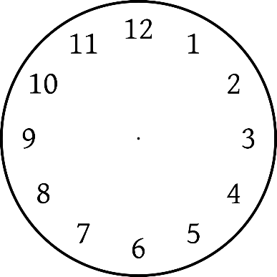

My Secondary School

My new school’s name: ..................................................................

School address:

School telephone number: .................................................................

Head Teacher’s Name: ..................................................................

New Form Tutor’s Name: ..................................................................

The school day starts at:

The school day finishes at:

Moving to Secondary School

Write up to four things you are excited about!

Moving to Secondary School

Write up to four things you are worried or nervous about…

Moving to Secondary School

Write up to four things that you help you feel better about moving school…

How I feel…

Tick whether you feel ‘okay’ or ‘not so okay’ about the following things…

|  |  |  |
| --- | --- | --- |
|  | Okay | Not So Okay |
| Finding my way around school |  |  |
| Making new friends |  |  |
| Break times |  |  |
| Lunch times |  |  |
| Wearing a new uniform |  |  |
| Learning new subjects |  |  |
| School rules |  |  |
| Meeting new teachers |  |  |
| Homework |  |  |
| Travelling to school |  |  |
| Being with older students |  |  |
| Getting changed for PE |  |  |
| Using the school toilets |  |  |

If there is anything you are worried about, you can speak to your new form tutor or someone from the pastoral support team.

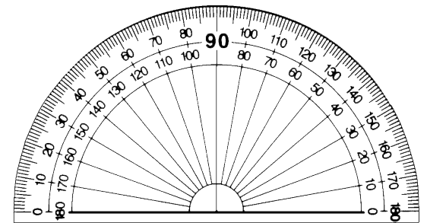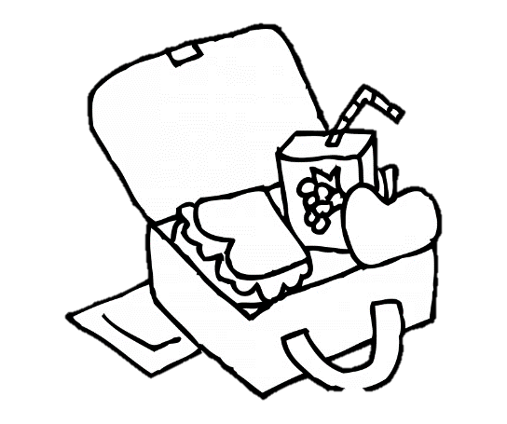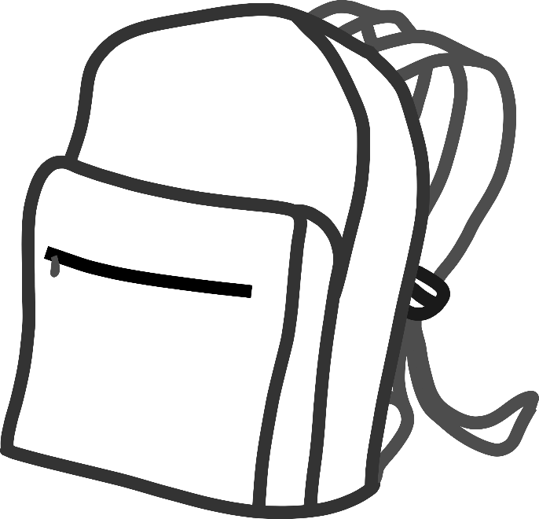

Equipment…

These are some of the items you will need in your bag each day. Colour them in and use this page as a reminder for when you pack your school bag.

My Journey to School

Write down how you will get to school, what time you will need to leave, and what time you expect to arrive at school

* ...............................................................................................
* ...............................................................................................
* ...............................................................................................
* ...............................................................................................

Now that you know the quickest and safest route you will take to school, let’s arrange a date and time to practice this journey.

Date: ...............................................................................................

Time I will leave: .............................................................................

How long will it take? .....................................................................

Who will come with me? .....................................................................

Coping on Your First Day

It is normal to feel nervous about going to a new school.

Write down some things you can say to yourself to make yourself feel calmer and more relaxed.

* Everyone is going to feel nervous like I am
* There will be lots of other students who do not know anyone
* I can do this
* ...................................................................................................
* ...................................................................................................
* ...................................................................................................

What other things could you do to help yourself feel better?

* Talk to a teacher about how I feel
* Talk to a friend or another student about my worries
* Take deep breaths, in through my nose and out through my mouth
* Try some of the relaxation techniques on the next page
* ...................................................................................................
* ...................................................................................................
* ...................................................................................................

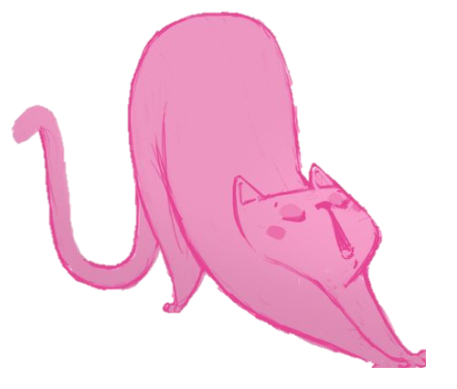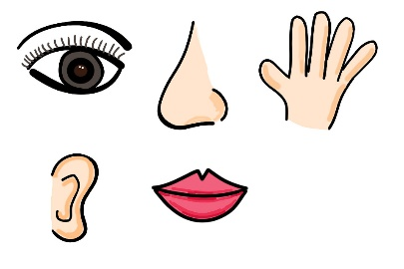

The Big Squeeze

This exercise relaxes the tension your muscles. Squeeze each of these body parts for 5 seconds and then release it.

Hands and arms, arms and shoulders, shoulders and neck, jaw, face and nose, stomach, legs and feet.

Making Lemonade

Imagine reaching up high and picking lemons from a tree with both hands. Squeeze the lemons in your fists until all the juice is out. Throw the lemons on the floor. Repeat until you have enough lemonade.

The Flower and The Candle

This exercise helps us take deep breaths.

Breathe in slowly through your nose as if you’re smelling a flower. Breathe out slowly through your mouth as if you’re blowing out a candle. Repeat a few times.

The Five Senses

This is a grounding technique. List **5** things you can **see**

**4** things you can **feel** **3** things you can **hear**

**2** things you can **smell** **1** thing you can **taste**

Relaxation Techniques